**SUNDAY 1st July 2018**

*Why not treat yourself as a* ***VIP*** *guest at* ***HOWDEN Show*** *2018. . . .*

We are delighted that the ***Kings Head,*** Barmby-on-the-Marsh will be again providing the catering. A family run business establishment who supply great food, homemade and locally sourced.

***PREMIER* Ticket**

 ***VIP Entry into Showground on 1st July 2018.***

 ***Entry into exclusive covered enclosure on Show Day.***

 ***Exclusive parking (Hard Standing) and Show entry.***

 ***Exclusive Ringside seating and table area (both main rings).***

 ***Pre-lunch drinks reception between 11am and noon.***

 ***A complimentary lunch served between 12noon and 2pm.***

 ***Table drinks service throughout the day.***

 ***Tea and cakes served between 2:30pm and 3:30pm.***

 ***Complimentary tea, coffee and biscuits refreshments available all day.***

**Adults : £27.50 Child 3—12 £15.00**

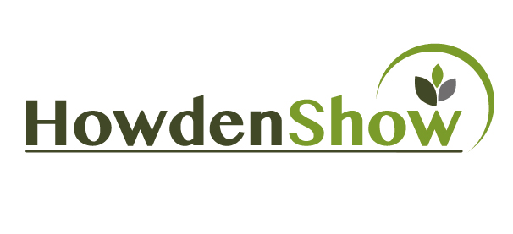

I / We would like to apply for a ***Premier***ticket(s) to the Howden Agricultural and Horticultural Show 2018.

I / We agree, if this application is accepted, to be bound by the rules of the Show

Title : Mr / Mrs / Miss / Dr / other ________

Name : ________________________________________________

Address : ________________________________________________

Post Code : _______________________

Tel : _______________________ **Email** : __________________________________

**: Renewal / New application** (Please Delete as appropriate)

|  |  |  |
| --- | --- | --- |
| Adult ***Premier***  £27.50 Each |  |  |
| Child (3—12 years of age) £15.00 Each |  |  |
| TOTALS |  |  |

***­­***Please make us aware of any dietary requirements

Cheques should be made payable to ‘**Howden Agriculture & Horticulture Show Limited’** and forwarded to:

**Contact Address ; Other Contact Details ;**

##### Mrs K Formon Tel : 01405 768900

##### 23 Station Road Mbl : 07970 445357

Howden, DN14 7AF Email : Karen@andrewsautomation.com

**PREMIER TICKETS ARE BY ADVANCE PURCHASE ONLY**

## *Premier Ticket Application Form 2018*

***Your support is greatly appreciated and will help in our work prompting British Farming and protection of our countryside.***

*Data will be held for marketing and auditing purposes only.*

**Howden Agriculture and Horticulture Show Limited**

Registered in England and Wales, Company No. 07537246 : Registered Charity No. 1146788

Registered Office - 17 Bridgegate, Howden, East Riding of Yorkshire, DN14 7AE

